Web 2.0

Initially Web 1.0 involved passively receiving information but as the internet evolved and became more collaborative users could directly influence the content on the web and the term Web 2.0 came into being. In one form it involves new knowledge sharing through mass amateurism in the form of news reporting, blogging or podcasts for example. This has changed from the traditional approach in Web 1.0 of solely ‘experts’ delivering media to the public at large. Web 2.0 gives users the opportunity to participate, collaborate, facilitate, interact and upload information. The future is looking to evolve towards web 3.0 technology which includes personalized access to the web, in particular through smart phones. Web 3.0 technology is predicted to be able to process the vast quantity of information available on the web for the user, providing a personalized response based on previous preferences.

Explore:

Posterous blogging:

1st: Me and Tom explored the use of posterous as a web 2.0 tool. We initially created a podcast using Garageband and used Cueprompter for the script. Then uploaded the podcast to our Posterous blog and linked the RSS to iTunes.

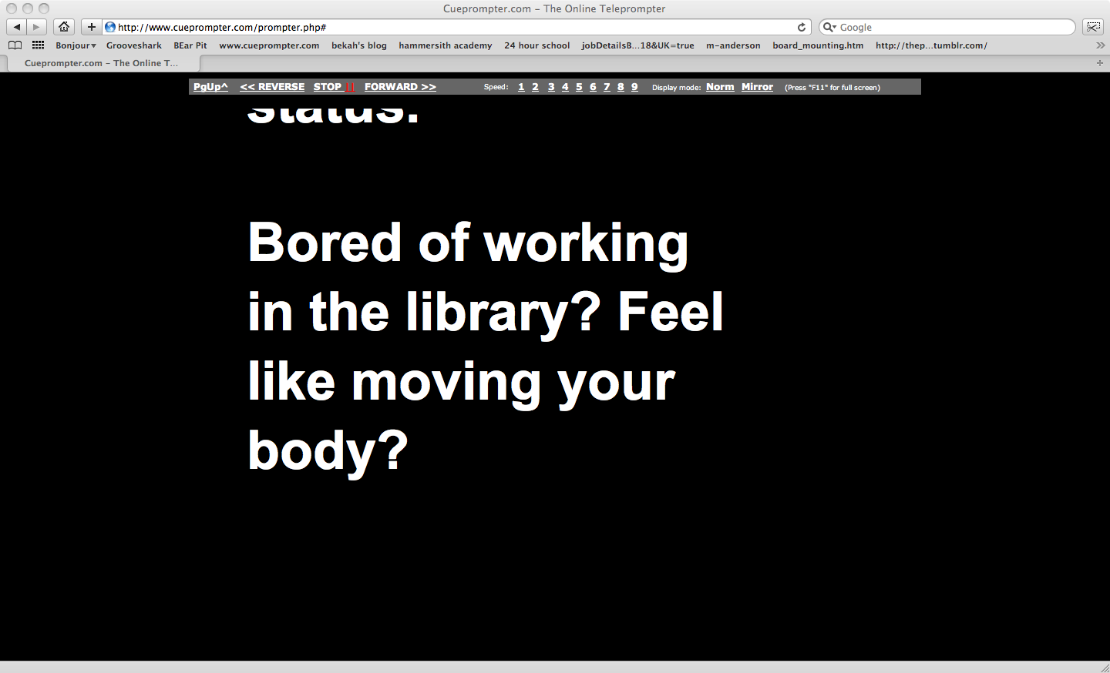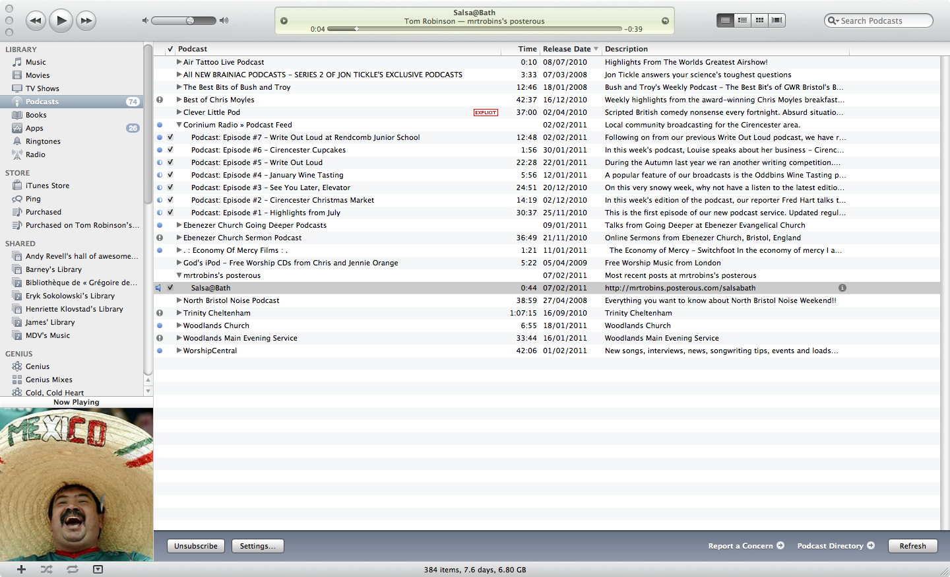

The RSS link makes it possible to put your podcast onto the iTunes store to reach a global audience using web 2.0.
- Definition of RSS:

Really Simple Syndication: a family of Web feed formats used to publish frequently updated works such as blog entries, news, headlines, audio and video.

2nd: We linked our posterous blog to our twitter feed, which created a direct link to the newly created blog.

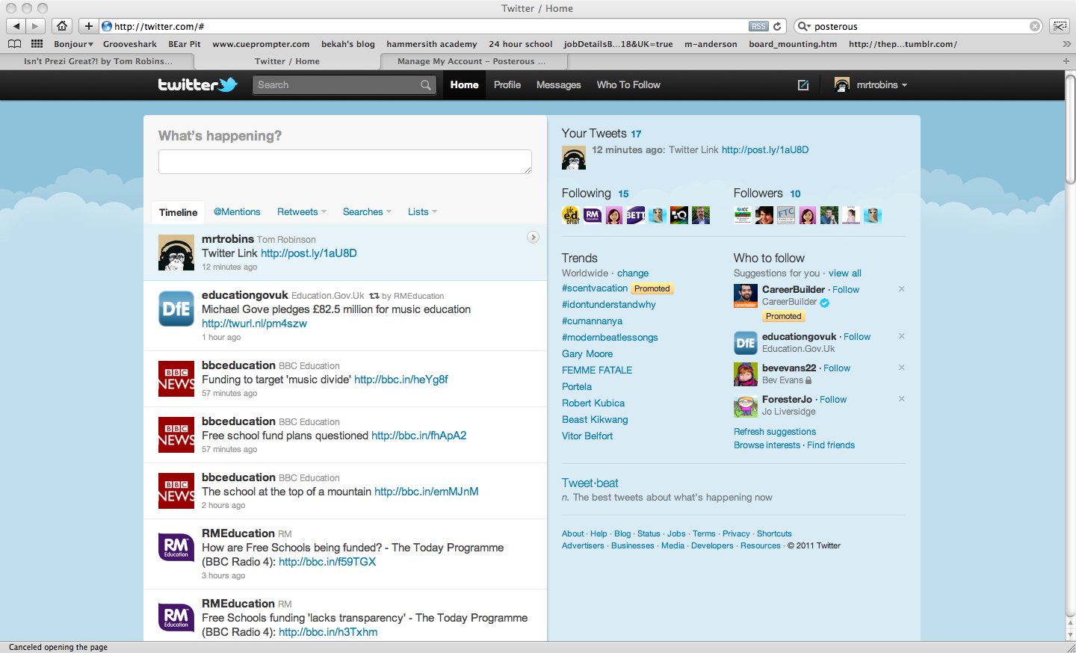

2nd Cloud computing with Prezi:

Secondly we create a presentation on flying penguins using Prezi. The file is stored online using cloud computing. The resulting presentation is then linked to Twitter, Facebook and Posterous.

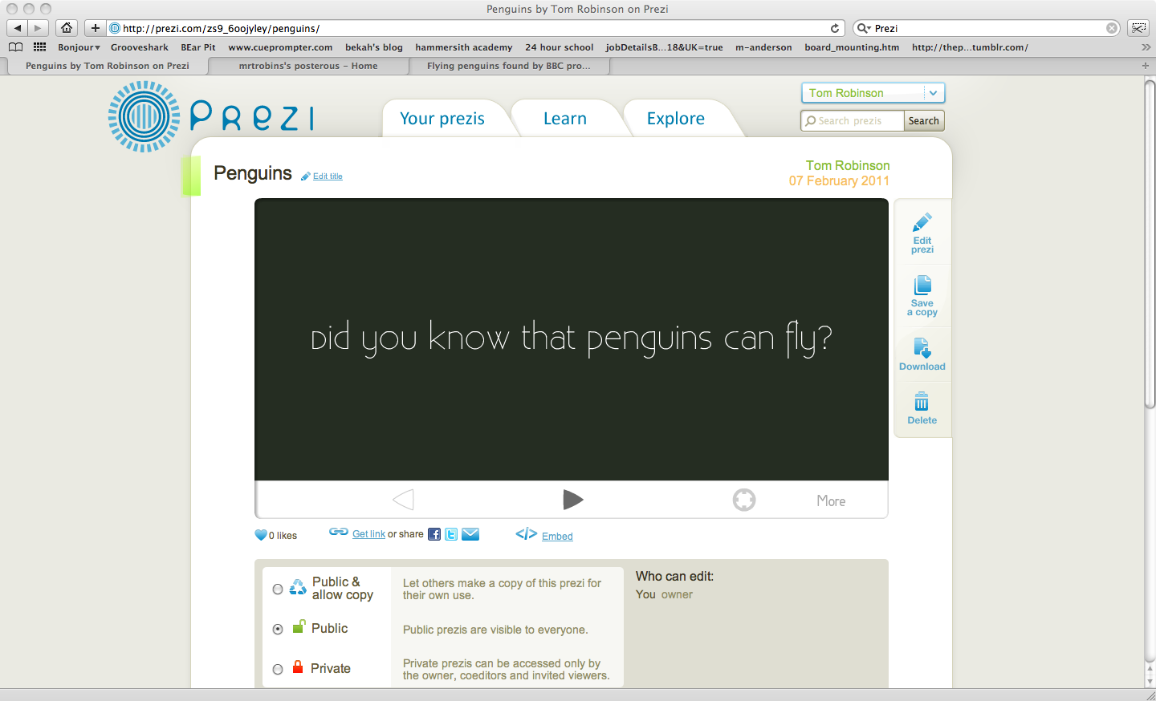

Possibilities, potentials and pitfalls for ICT classroom:

- Giving students access to teaching materials thus removing the need for a VLE or note taking by the pupils.
- Sharing ideas in the form of CPD with ICT colleagues across the UK and the world.
- Using podcasting to communicate the school news to parents or other interested 3rd parties.
- Providing more memorable lessons. More relevant to the students personal lives and experiences, which makes ICT more engaging. Gives the pupils a sense of ownership if directly contributing to the lesson materials.

Pitfalls:

- Control of web 2.0 content

- Accuracy of web 2.0 content, especially important when used as a teaching resource.

- Copyright issues.

- Streaming issues if using cloud computing.

- Online, people could post more radical or malicious content due to a feeling of reduced consequences than they would if in person.

